BLOCKCHAIN-SPECIFIC UNIT TESTS

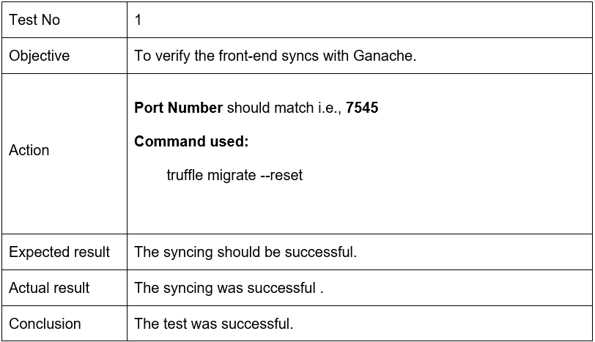
Table: Blockchain Test Case 1

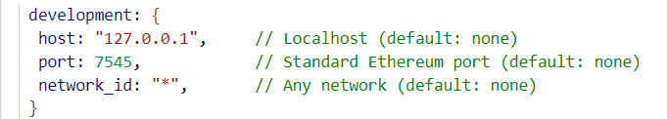
Figure; Truffle-config

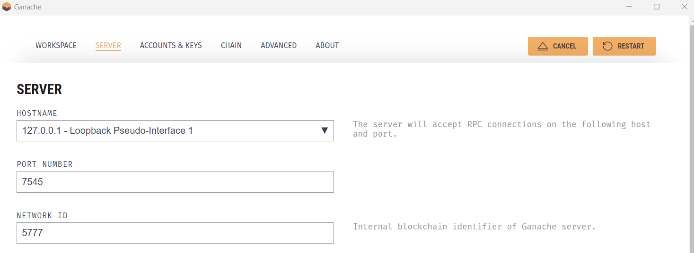
Figure: Ganache- Server

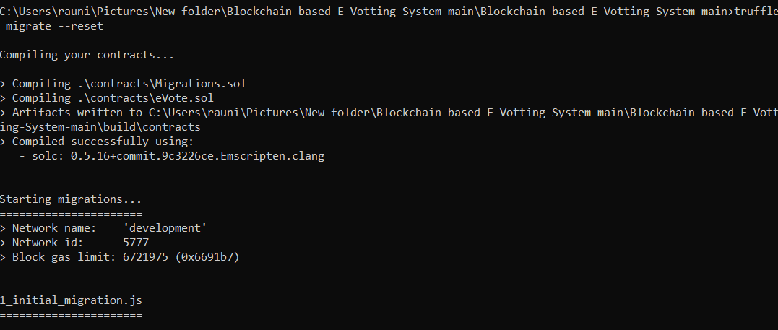
Figure: Compiling Contract

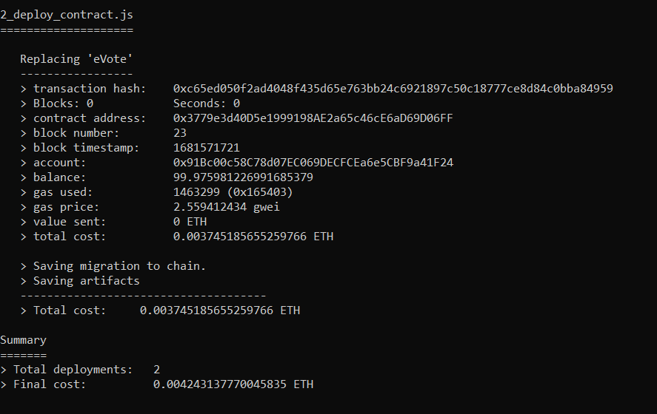
Figure: Compiled Contract

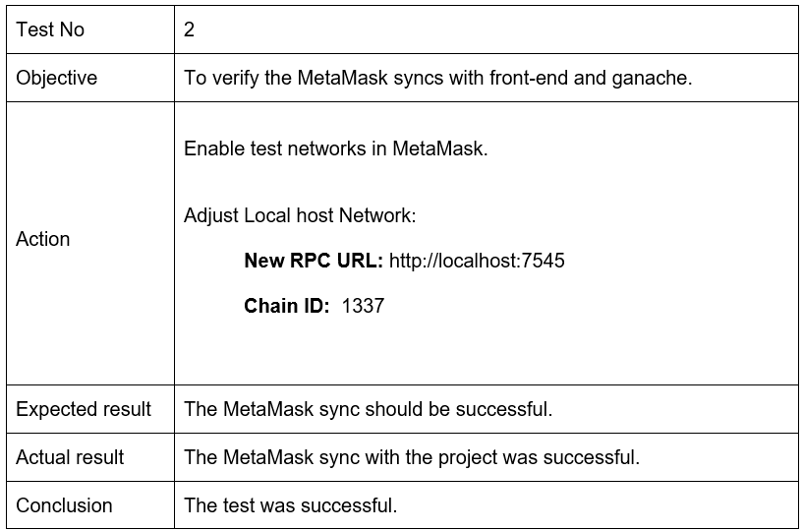
Table: Blockchain Test Case 2

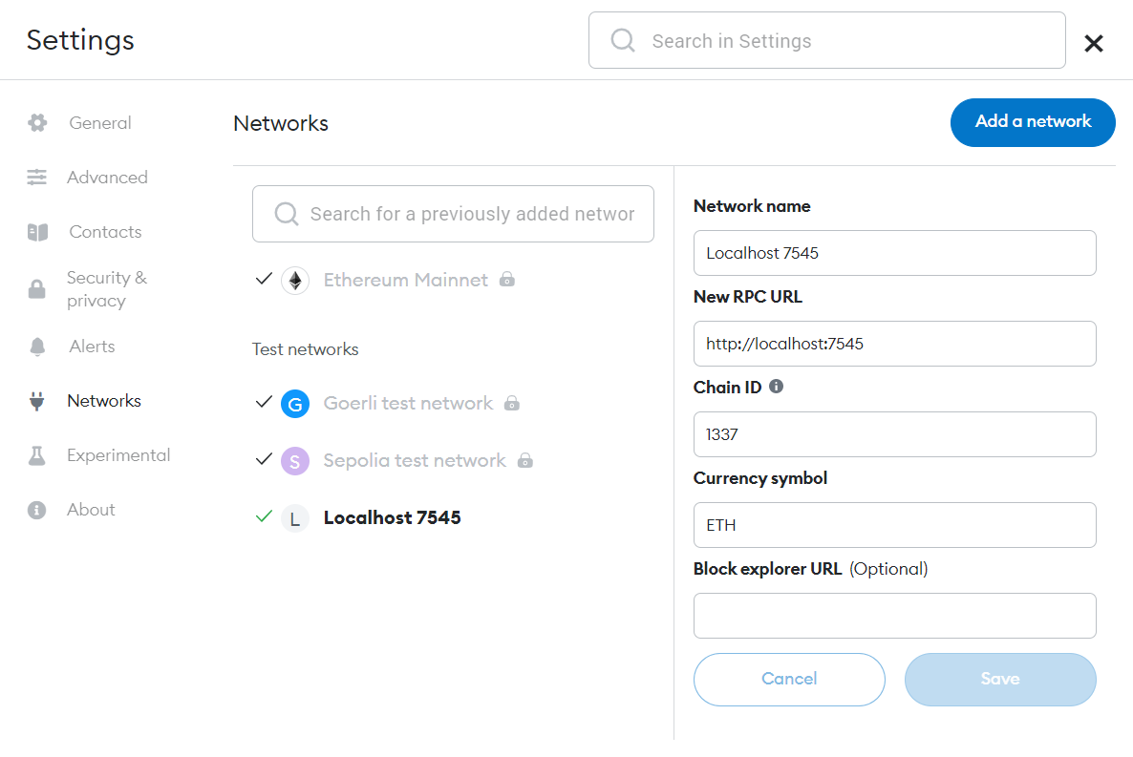
Figure: MetaMask- Local Network

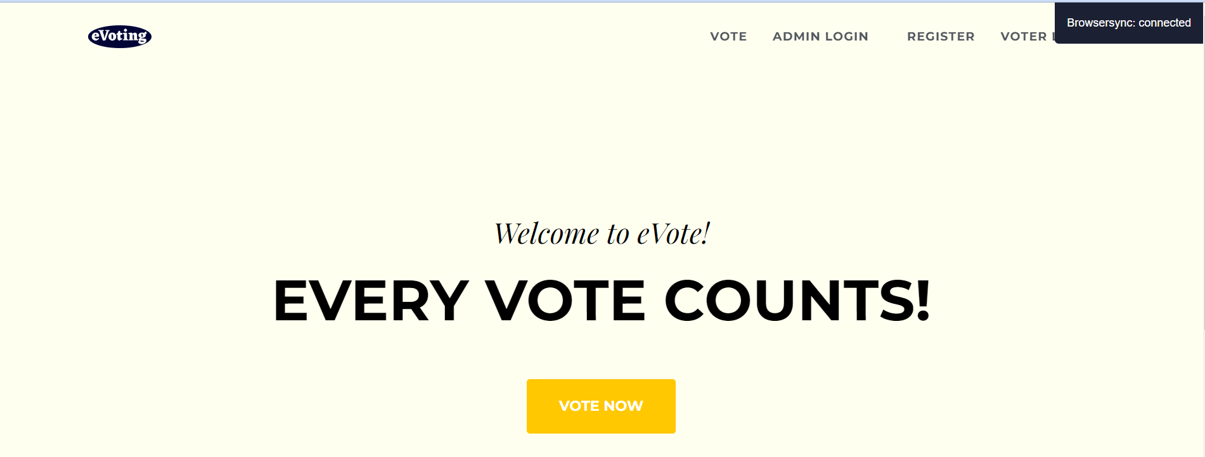
Figure: Front-End Synced with MetaMask

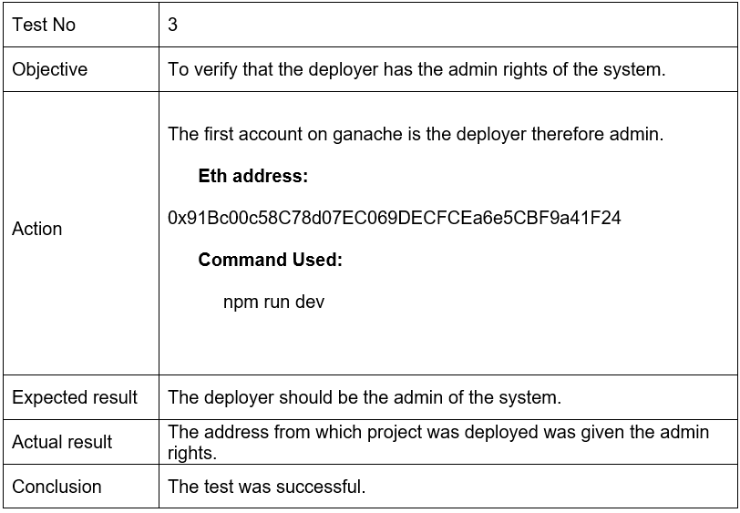
Table: Blockchain Test Case 3
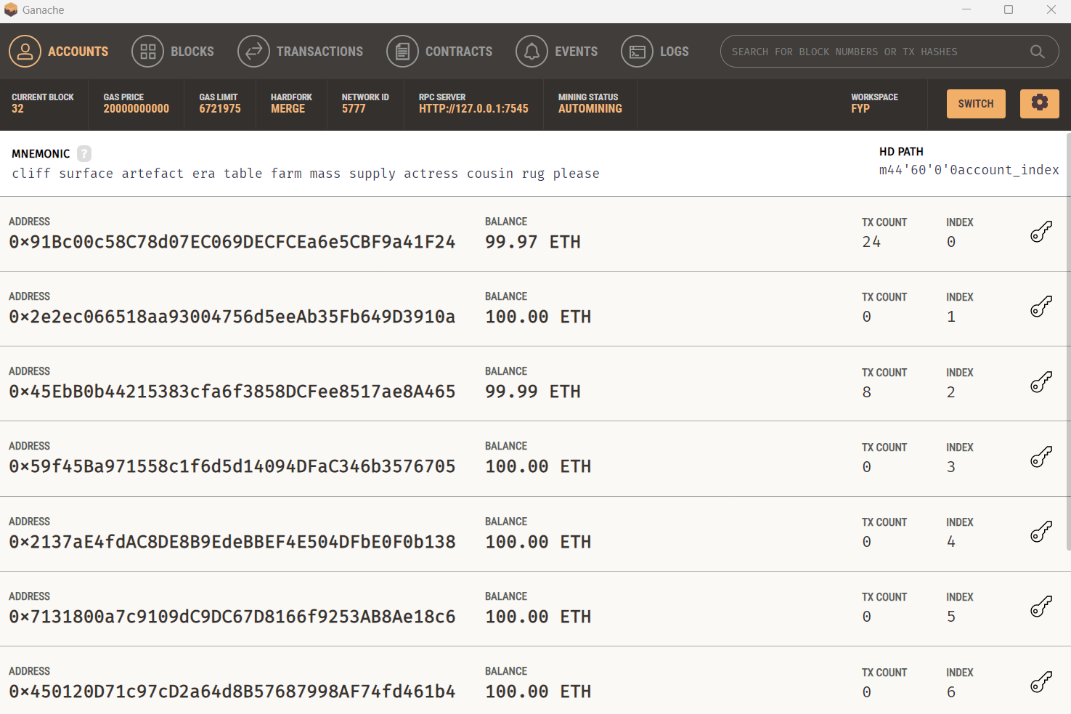
Figure: Ganache- Homepage

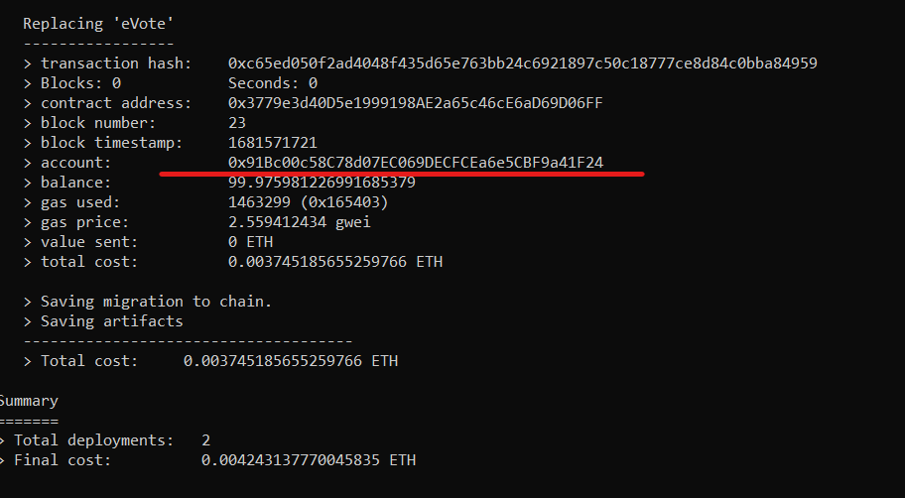
Figure: Deployed Address

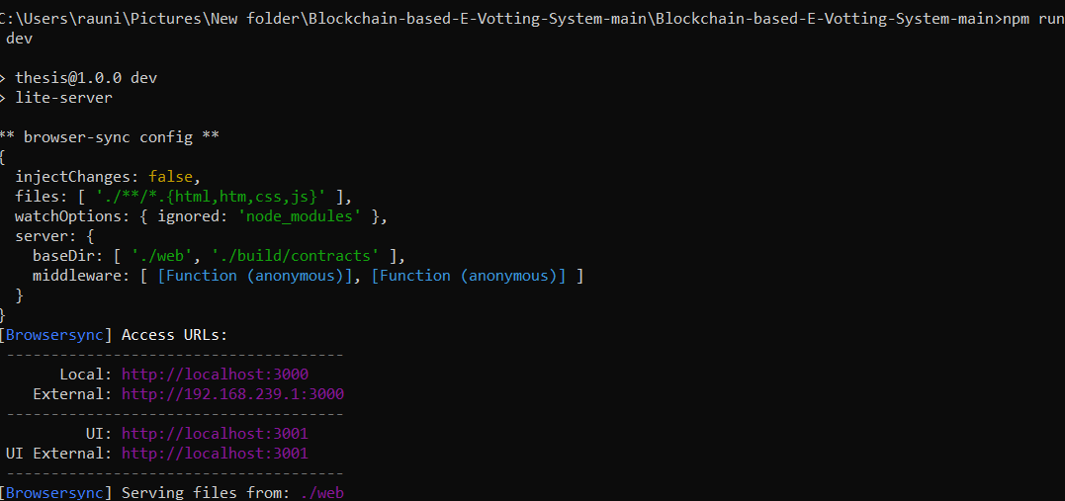
Figure: Deploying Project

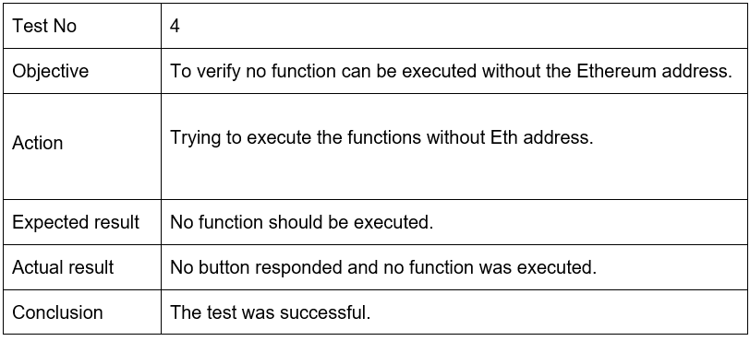
Table: Blockchain Test Case 4

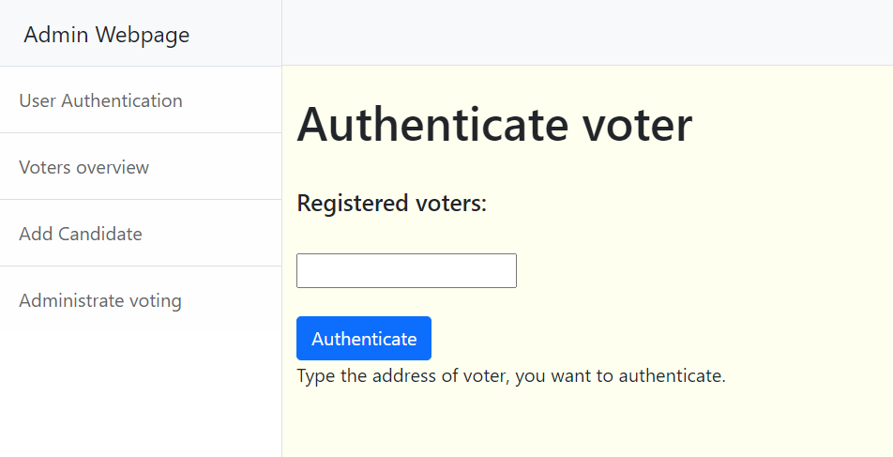
Figure: Authenticate Voter

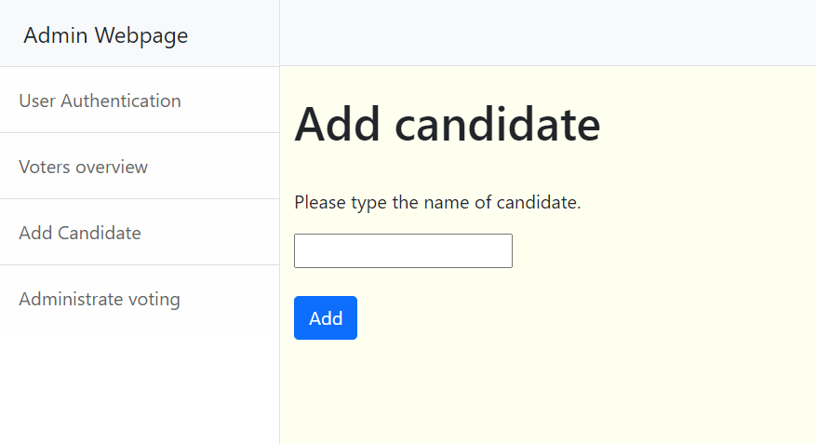
Figure: Add Candidate


Figure: Voter Login

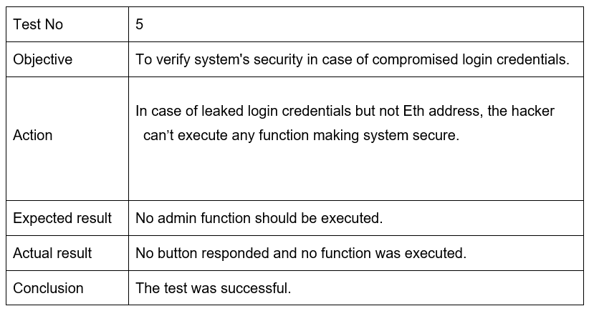
Table: Blockchain Test Case 5

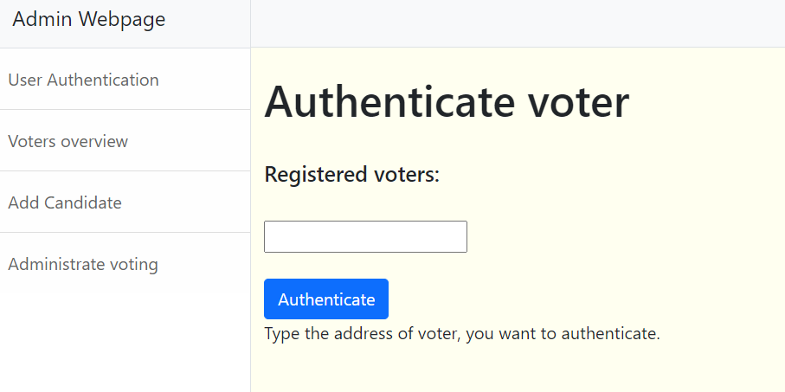
Figure: Authenticate Voter

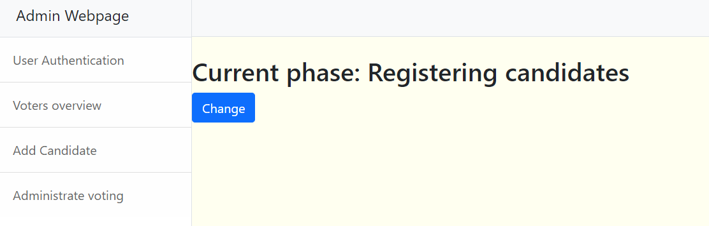
Figure: Registering Candidates

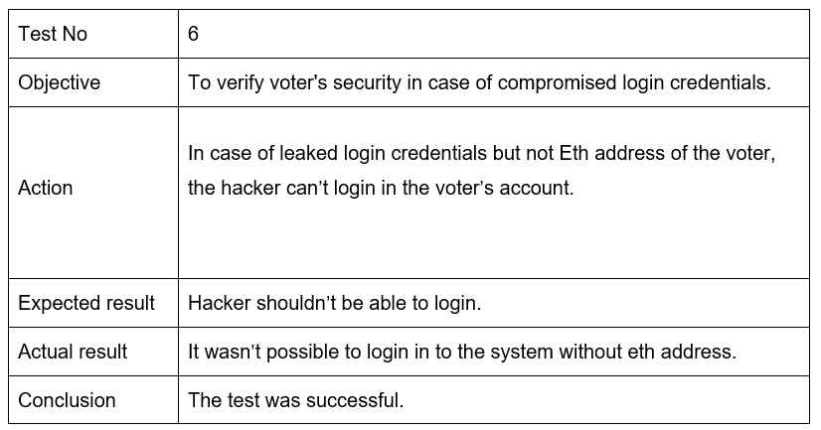
Table: Blockchain Test Case 6


Figure: Voter Login

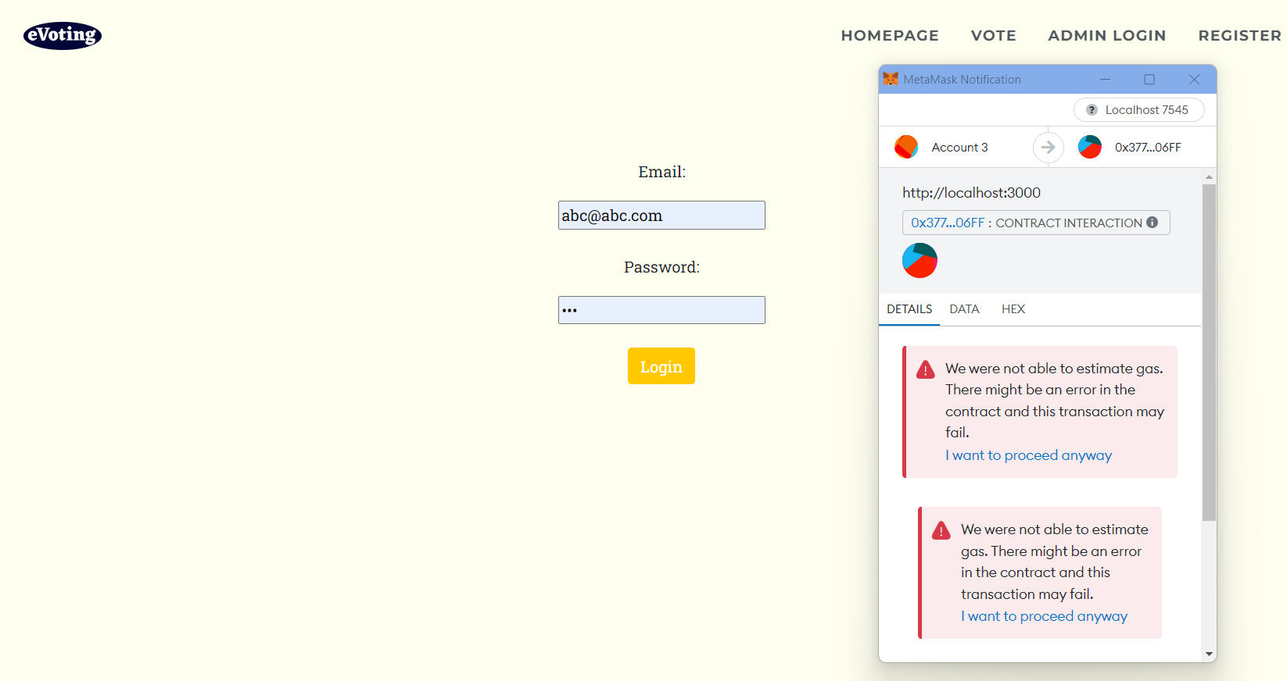
Figure: Error in Transaction

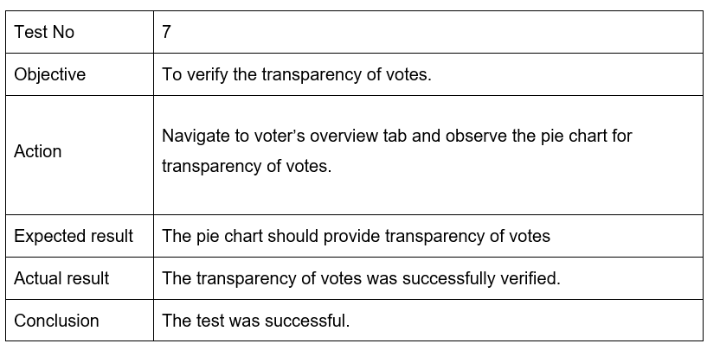
Table: Blockchain Test Case 7

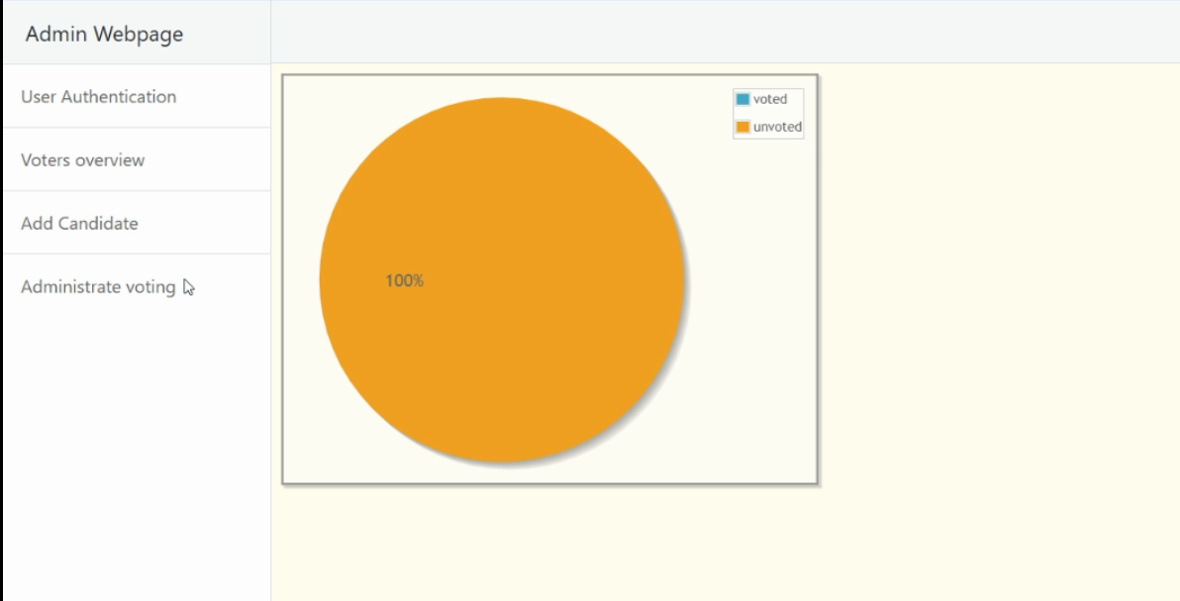
Figure: Analytics- Not Voted

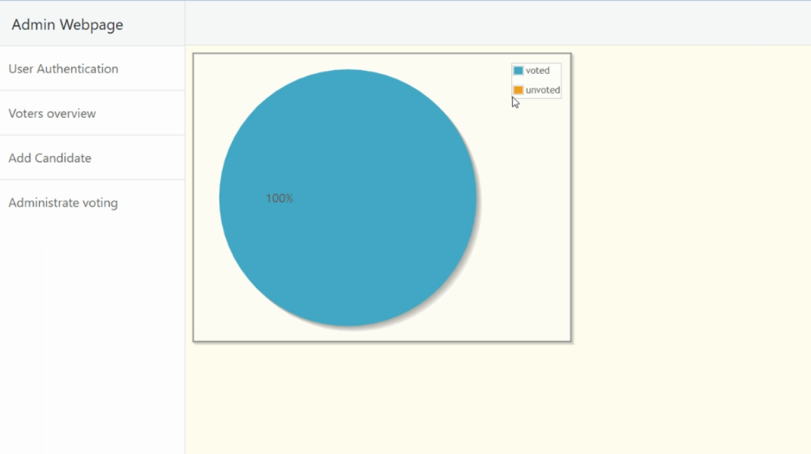
Figure: Analytics- Voted

